

v1.2.0

06-September-2022

USER MANUAL

A10-vThunder\_ADC-HYBRID-CLOUD-GSLB

# PATENT PROTECTION

A10 Networks, Inc. products are protected by patents in the U.S. and elsewhere. The following website is provided to satisfy the virtual patent marking provisions of various jurisdictions including the virtual patent marking provisions of the America Invents Act. A10 Networks, Inc. products, including all Thunder Series products, are protected by one or more of U.S. patents and patents pending listed at: a10-virtual-patent-marking.

# TRADEMARKS

A10 Networks, Inc. trademarks are listed at: a10-trademarks.

# CONFIDENTIALITY

This document contains confidential materials proprietary to A10 Networks, Inc. This document and information and ideas herein may not be disclosed, copied, reproduced, or distributed to anyone outside A10 Networks, Inc. without prior written consent of A10 Networks, Inc.

# DISCLAIMER

This document does not create any express or implied warranty about A10 Networks, Inc. or about its products or services, including but not limited to fitness for a particular use and non-infringement. A10 Networks, Inc. has made reasonable efforts to verify that the information contained herein is accurate, but A10 Networks, Inc. assumes no responsibility for its use. All information is provided "as-is." The product specifications and features described in this publication are based on the latest information available; however, specifications are subject to change without notice, and certain features may not be available upon initial product release. Contact A10 Networks, Inc. for current information regarding its products or services. A10 Networks, Inc. products and services are subject to A10 Networks, Inc. standard terms and conditions.

# ENVIRONMENTAL CONSIDERATIONS

Some electronic components may possibly contain dangerous substances. For information on specific component types, please contact the manufacturer of that component. Always consult local authorities for regulations regarding proper disposal of electronic components in your area.

# FURTHER INFORMATION

For additional information about A10 products, terms and conditions of delivery, and pricing, contact your nearest A10 Networks, Inc. location, which can be found by visiting [www.a10networks.com](http://www.a10networks.com/" \t "_blank).

Contents

[PATENT PROTECTION 1](#_Toc140483045)

[TRADEMARKS 1](#_Toc140483046)

[CONFIDENTIALITY 1](#_Toc140483047)

[DISCLAIMER 1](#_Toc140483048)

[ENVIRONMENTAL CONSIDERATIONS 1](#_Toc140483049)

[FURTHER INFORMATION 1](#_Toc140483050)

[Introduction to Installing vThunder on Microsoft Azure 3](#_Toc140483051)

[Overview of Microsoft Azure 4](#_Toc140483052)

[Azure Terminology 6](#_Toc140483053)

[Azure Prerequisites 7](#_Toc140483054)

[System Requirements 8](#_Toc140483055)

[Chapter 1 - 8](#_Toc140483056)

[Chapter 1 - GSLB Setup 8](#_Toc140483057)

[There are two options to setup GSLB. 9](#_Toc140483058)

[Architecture – Azure-To-Azure Cloud 9](#_Toc140483059)

[Architecture – Azure-To-On-Premises 9](#_Toc140483060)

[Step1: Setup Location 01 10](#_Toc140483061)

[Step2: Setup Location 02 10](#_Toc140483062)

[Step 3 : Setup GSLB Configuration 10](#_Toc140483063)

[3.1 10](#_Toc140483064)

[Provide required information in ARM\_TMPL\_HYBRID\_CLOUD\_CONFIG\_GSLB\_PARAM.json 10](#_Toc140483065)

[Install 14](#_Toc140483066)

[Step 4: Verify 15](#_Toc140483067)

[DNS Query Testing 27](#_Toc140483068)

[Verify Traffic on load balancer using WGET 30](#_Toc140483069)

# Introduction to Installing vThunder on Microsoft Azure

vThunder for Microsoft Azure is a fully operational, software-only version of the ACOS Series Server Load Balancer (SLB), or Application Delivery Controller (ADC) device. It is configurable by ACOS CLI, GUI, AXAPI, and Harmony Controller.

vThunder is a virtual appliance, yet it retains most of the functionality available on the hard- ware based ACOS appliances. Managing vThunder is the same as managing hardware based ACOS device, and vThunder has the same CLI configurations and GUI presentation.

The networking configuration for vThunder is also like hardware based ACOS devices. The maximum throughput of vThunder for Azure is variable and depends on vThunder software license purchase and type instance used to deploy vThunder.

*A10 Networks brings Out-Of-Box template to deploy vThunder along with multiple features and functionality with pre-defined format into azure cloud.*

Please refer below section for more details.

# Overview of Microsoft Azure

With the move to the cloud, many teams have adopted agile development methods. These teams iterate quickly. They need to repeatedly deploy their solutions to the cloud, and know their infrastructure is in a reliable state. As infrastructure has become part of the iterative process, the division between operations and development has disappeared. Teams need to manage infrastructure and application code through a unified process.

To meet these challenges, you can automate deployments and use the practice of infrastructure as code. In code, you define the infrastructure that needs to be deployed. The infrastructure code becomes part of your project. Just like application code, you store the infrastructure code in a source repository and version it. Any one on your team can run the code and deploy similar environments.

To implement infrastructure as code for your Azure solutions, use azure resource manager templates. The template is a json native file that defines the infrastructure and configuration for your project. The template uses declarative syntax, which lets you state what you intend to deploy without having to write the sequence of programming commands to create it. In the template, you specify the resources to deploy and the properties for those resources.

**Microsoft Azure** (formerly known as Windows Azure) is Microsoft’s cloud computing platform. Azure is an industry leader for both infrastructure-as-a-service (IaaS) and platform-as-a-service (PaaS). Azure offers a combination of managed and unmanaged services that lets customers deploy and manage their applications as they see fit.

The Azure cloud computing platform runs on Microsoft data center and is globally dis- tributed across more than a dozen countries. Such global distribution helps ensure customers receive high performance, regardless of where they are located.

Azure is flexible and can support virtually any operating system, from Windows to Linux, any programming language, from Java to C++, and any database, from SQL to Oracle. Azure also offers 99.95% uptime and is the platform that Microsoft uses to run many of its popular ser- vices, such as Bing, Skype, Xbox, and Office 365.

A10 Networks vThunder virtual device can be set up as an instance in Azure’s cloud and can be used to provide a robust global server load balancing (GSLB) service.

Microsoft Azure uses the following tools to create and manage resources:

**Azure Portal** - A web console to create and monitor Azure resources. For more information, refer to <https://azure.microsoft.com/en-in/features/azure-portal/>

**Azure PowerShell** - A set of cmdlets used for managing Azure resources from the command line. Launch Azure PowerShell from a browser within the Azure Cloud Shell or install the software on the system to start a local PowerShell session.

For more information, refer to <https://docs.microsoft.com/en-us/powershell/>

**Azure CLI—** Can also be launched from a browser within the Azure Cloud Shell or install the software on the system to start a local CLI session. For more information, refer to <https://docs.microsoft.com/en-us/cli/azure/overview?view=azure-cli-latest>

You **can** launch Cloud Shell from the top navigation bar of the Azure portal.

FIGURE 1-1: Launching Cloud Shell



The following figure shows how vThunder fits into the Microsoft Azure infrastructure.

FIGURE 1-2: vThunder for Microsoft Azure

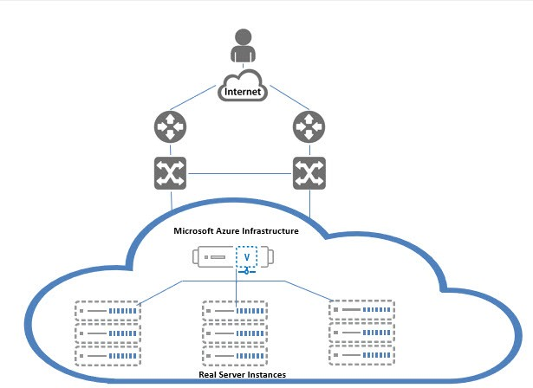

Below diagram shows the topology of 2 regions GSLB. 1 GSLB controller and 2 site devices in each region.

FIGURE 1-3: GSLB Topology

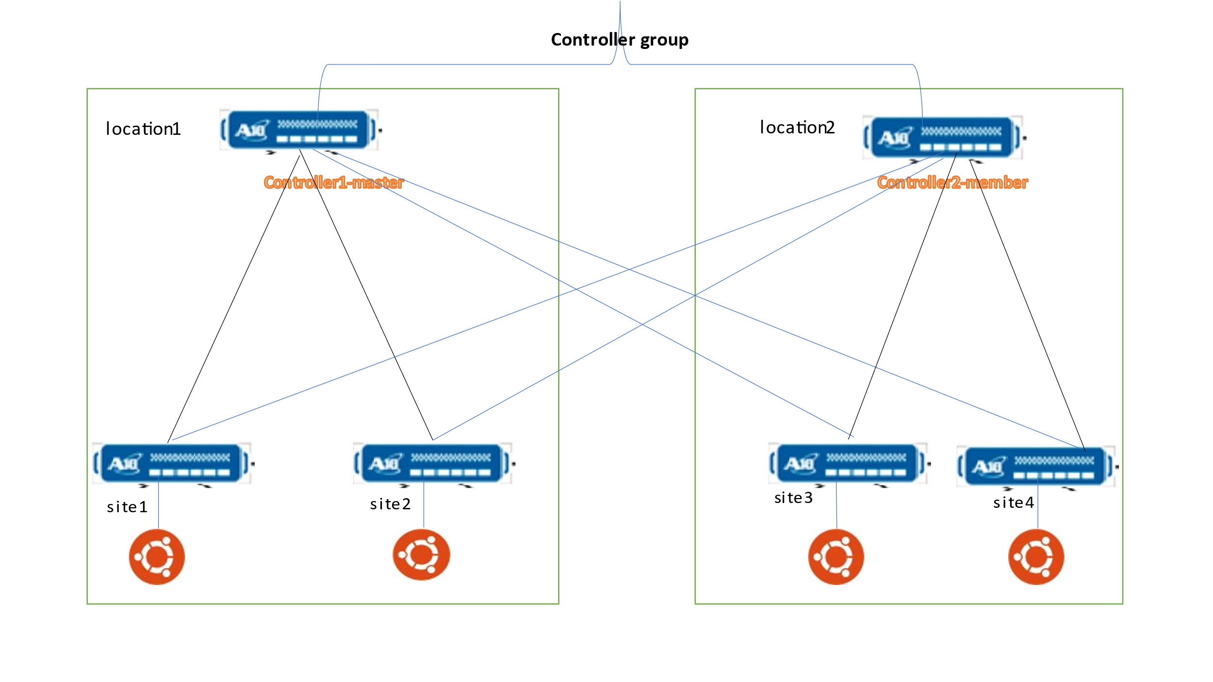

# Azure Terminology

**Azure account** — The Azure account created has different support plans for different regions. For more information on different Azure regions and availability of types of virtual machines in these regions, refer to

<https://docs.microsoft.com/en-us/azure/virtual-machines/linux/overview>

**Resource group** — A resource group is a logical group of all the resources related to an Azure solution. Azure offers flexibility in the allocation of resources to resource groups.

For more information, refer to

[https://docs.microsoft.com/en-us/azure/azure-resource-manager/resource-group- overview](https://docs.microsoft.com/en-us/azure/azure-resource-manager/resource-group-%20overview/)

**Availability set** — An availability set is a logical grouping of Azure VM resources so that each VM resource is isolated from other resources when deployed. This hardware isolation ensures that a minimum number of VMs are impacted during a failure. For more information, refer to

[https://docs.microsoft.com/en-us/azure/azure-resource-manager/resource-group- overview](https://docs.microsoft.com/en-us/azure/azure-resource-manager/resource-group-%20overview/)

**Virtual network** — The Microsoft Azure Virtual Network service enables resources to securely communicate with other resources in an Azure network in the cloud. A virtual network is hence logical isolation of the Azure cloud for an Azure account. You can con- nect different virtual networks and to on-premises networks. For more information, refer to

[https://docs.microsoft.com/en-us/azure/virtual-machines/windows/tutorial-avail- ability-sets](https://docs.microsoft.com/en-us/azure/virtual-machines/windows/tutorial-avail-%20ability-sets/)

**Network security group (NSG)** — A network security group (NSG) contains a list of security rules that allow or deny network traffic to resources connected to Azure virtual networks (VNET). The NSGs can be associated with subnets or individual NICs attached to the VMs. When an NSG is associated with a subnet, the rules apply to all the resources connected to the subnet.

## Azure Prerequisites

1. Azure Account & Subscription.
2. Environment Setup to Run hybrid configuration python script Template [One Time Step]
3. Download and install python setup using following link:

<https://www.python.org/ftp/python/3.8.5/python-3.8.5-amd64.exe>

1. To verify that Python is available on our local machine, we need to open the command line (in Windows search, type cmd and press Enter to open Command Prompt or right-click on the Start button and select Windows Command Prompt), type python, and press Enter.
2. If Python is properly installed, we will see a notification like the one below

*Python 3.8.x (tags/v3.10.2:a58ebcc, Jan 17 2022, 14:12:15) [MSC v.1929 64 bit (AMD64)] on win32 Type "help," "copyright," "credits," or "license" for more information.*

1. To check if PIP is already installed on Windows, we should open the command line again, type pip, and press Enter.
2. If PIP is installed, we will receive a long notification explaining the program usage, all the available commands and options. Otherwise, if PIP is not installed, the output will be:

*'pip' is not recognized as an internal or external command, operable program or batch file.*

1. To install pip on window visit:

[https://pip.pypa.io/en/stable/installation](https://pip.pypa.io/en/stable/installation/)

1. Install all dependencies go to current working directory and use following command:

pip install -r requirements.txt

## System Requirements

**Interfaces**

Three interfaces (1 Management, 2 Data) for 3 vThunder will be required in each GSLB location.



**Subnets**

Three subnets will be created in each GSLB region.

**Virtual Private Network**

A virtual Private network will be created eg. Address prefix is 10.0.1.0/16.

**Public Ip**

Public Ip will be created and attached to management and data interface of vThunder instances.

**Security Group**

For each A10 device, the management, client-side data interface and server-side data interface have security group assigned with Allow permissions for relevant ports.

Two security groups will be created 1 for management and another for client-side data interface and server-side data interface.

**vThunder Instance**

In each GSLB region 3 vThunder and 2 Linux server instance will be required.

# Chapter 1 - Chapter 1 - GSLB Setup

GSLB consist of two location and both locations should be identical with configuration and components and that too taken care by GSLB auto sync configuration.

Minimum GSLB configuration is for two locations.

Any one setup can be known as master and other called as member.

Each location consist minimal set of thunder like:

* Controller [Thunder Instance - Acting as DNS server that directs client to reach health load balancer]
* Site 1        [Thunder Instance - Acting as a load balancer and sends traffic to servers]
* Site 2        [Thunder Instance - Acting as a load balancer and sends traffic to servers]

## There are two options to setup GSLB.

* Azure to Azure.
  + azure-to-azure (location 1 and location 2 both is in azure cloud).
* Azure to On-Premises(any).
  + azure-to-on-premises (any one location is in azure and another location is in in on-premises)

HYBRID-CLOUD-CONFIG Template provides automated scripts in python to apply SLB and GSLB configurations into both locations either on-premises or azure cloud.

## Architecture – Azure-To-Azure Cloud

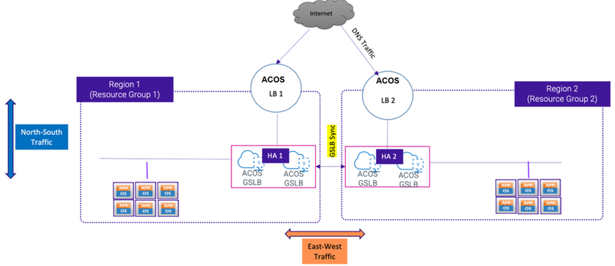

## Architecture – Azure-To-On-Premises

Note:

* 1. A10 provides one template ‘[3NIC-3VM’](http://www.google.com) which creates three thunder instances into Azure cloud.
  2. Template does not provide installation setup for on-premises. One has to follow respective document to install basic three thunder Instance in on-premises.

## Step1: Setup Location 01

1. In case location is azure cloud, then run [ARM\_TMPL\_3NIC\_3VM](https://gitlab.a10networks.com/ax/a10-azure-arm-templates-internal/-/tree/feature/1.2.0_ip_forwarding/ARM-TEMPLATES/A10-vThunder_ADC-3NIC-3VM-2RG-GSLB) template in azure cloud using quick launch link in readme or by uploading the ARM template from local. This will install three vThunder only, no SLB or GSLB config will apply.
2. In case location is on-premises, then create three instances of Thunder and associate with network interface card. Follow the respective on-premises installation guidelines. Need to do only basic Thunder installation, no need to do any SLB or GSLB config.

## Step2: Setup Location 02

1. In case location is azure cloud, then run [ARM\_TMPL\_3NIC\_3VM](https://gitlab.a10networks.com/ax/a10-azure-arm-templates-internal/-/tree/feature/1.2.0_ip_forwarding/ARM-TEMPLATES/A10-vThunder_ADC-3NIC-3VM-2RG-GSLB) template in azure cloud using quick launch link in readme or by uploading the ARM template from local. This will install three vThunder only, no SLB or GSLB config will apply.
2. In case location is on-premises, then create three instances of Thunder and associate with network interface card. Follow the respective on-premises installation guidelines. Need to do only basic Thunder installation, no need to do any SLB or GSLB config.

## Step 3 : Setup GSLB Configuration

## 3.1 Provide required information in ARM\_TMPL\_HYBRID\_CLOUD\_CONFIG\_GSLB\_PARAM.json

* Many configuration user can keep default or change as per the requirements.
* There are 3 instances you can choose any one as master and other two will be site devices.
* First Provide parameters for **Master Controller** which we call as Location 1 of GSLB. Please find below sample information if resources created in azure using 3NIC-3VM template.

**Master Controller:**

|  |  |  |  |
| --- | --- | --- | --- |
| **Parameters** | **Descriptions** | **Default values** | **Reference**  **Link** |
| controllerMngmtPublicIp | Public Ip of Management | 104.45.152.126 | [ARM\_TMPL\_3NIC\_3VM\_ANNEXURE\_1](http://www.google.com) |
| controllerPassword | vThunder’s Login password | a10 | [ARM\_TMPL\_3NIC\_3VM\_ANNEXURE\_1](http://www.google.com) |
| controllerSecPrivateIpData1 | Secondary Pvt Ip of Data Interface 1 | 10.1.20.8 | [ARM\_TMPL\_3NIC\_3VM\_ANNEXURE\_1](http://www.google.com) |
| site1MngmtPublicIp | Public IP of Management Interface | 20.163.190.244 | [ARM\_TMPL\_3NIC\_3VM\_ANNEXURE\_1](http://www.google.com) |
| site1Password | vThunder’s Login password of Location1 Site1 Vthunder | a10 | [ARM\_TMPL\_3NIC\_3VM\_ANNEXURE\_1](http://www.google.com) |
| site2MngmtPublicIp | Public Ip of Management Interface of Location1 Site2 | 20.85.217.94 | [ARM\_TMPL\_3NIC\_3VM\_ANNEXURE\_1](http://www.google.com) |
| site2Password | vThunder’s Login password of Location1 Site2 Vthunder | a10 | [ARM\_TMPL\_3NIC\_3VM\_ANNEXURE\_1](http://www.google.com) |
| site1SecPrivateIpData1 | Secondary Pvt Ip of DataSubnet1 of Location1 Site1 vThunder | 10.1.20.9 | [ARM\_TMPL\_3NIC\_3VM\_ANNEXURE\_1](http://www.google.com) |
| site1SecPublicIpData1 | Secondary Public Ip of DataSubnet1 of Location1 Site1 vThunder | 20.163.190.244 | [ARM\_TMPL\_3NIC\_3VM\_ANNEXURE\_1](http://www.google.com) |
| site2SecPrivateIpData1 | Secondary Pvt Ip of DataSubnet1 of Location1 Site2 vThunder | 10.1.20.10 | [ARM\_TMPL\_3NIC\_3VM\_ANNEXURE\_1](http://www.google.com) |
| site2SecPublicIpData1 | Secondary Public Ip of DataSubnet1 of Location1 Site2 vThunder | 20.85.217.94 | [ARM\_TMPL\_3NIC\_3VM\_ANNEXURE\_1](http://www.google.com) |
| server1PrivateIp | Private Ipv4 address of server1 of Location1 | 10.2.20.9 | [ARM\_TMPL\_3NIC\_3VM\_ANNEXURE\_1](http://www.google.com) |
| server2PrivateIp | Private Ipv4 address of server1 of Location2 | 10.2.20.10 | [ARM\_TMPL\_3NIC\_3VM\_ANNEXURE\_1](http://www.google.com) |

**Member Controller :**

|  |  |  |  |
| --- | --- | --- | --- |
| **Parameters** | **Descriptions** | **Default values** | **Reference**  **Link** |
| controllerMngmtPublicIp | Public ip address of management interface. | 20.124.0.232 | [ARM\_TMPL\_3NIC\_3VM\_ANNEXURE\_1](http://www.google.com) |
| controllerPassword | Password to login into thunder. | a10 | [ARM\_TMPL\_3NIC\_3VM\_ANNEXURE\_1](http://www.google.com) |
| controllerSecPrivateIpData1 | Secondary ip address of data interface 1. | 10.1.20.14 | [ARM\_TMPL\_3NIC\_3VM\_ANNEXURE\_1](http://www.google.com) |
| site1MngmtPublicIp | Public Ip of Management Interface of Location1 Site1 | 20.163.190.244 | [ARM\_TMPL\_3NIC\_3VM\_ANNEXURE\_1](http://www.google.com) |
| site1Password | vThunder’s Login password of Location2 Site1 Vthunder | a10 | [ARM\_TMPL\_3NIC\_3VM\_ANNEXURE\_1](http://www.google.com) |
| site2MngmtPublicIp | Public Ip of Management Interface of Location2 Site2 | 20.85.217.94 | [ARM\_TMPL\_3NIC\_3VM\_ANNEXURE\_1](http://www.google.com) |
| site2Password | vThunder’s Login password of Location2 Site2 Vthunder | a10 | [ARM\_TMPL\_3NIC\_3VM\_ANNEXURE\_1](http://www.google.com) |
| site1SecPrivateIpData1 | Secondary Pvt Ip of DataSubnet1 of Location2 Site1 vThunder | 10.1.20.15 | [ARM\_TMPL\_3NIC\_3VM\_ANNEXURE\_1](http://www.google.com) |
| site1SecPublicIpData1 | Secondary Public Ip of DataSubnet1 of Location2 Site1 vThunder | 20.65.88.231 | [ARM\_TMPL\_3NIC\_3VM\_ANNEXURE\_1](http://www.google.com) |
| site2SecPrivateIpData1 | Secondary Pvt Ip of DataSubnet1 of Location2 Site2 vThunder | 10.1.20.16 | [ARM\_TMPL\_3NIC\_3VM\_ANNEXURE\_1](http://www.google.com) |
| site2SecPublicIpData1 | Secondary Public Ip of DataSubnet1 of Location2 Site2 vThunder | 20.65.95.155 | [ARM\_TMPL\_3NIC\_3VM\_ANNEXURE\_1](http://www.google.com) |
| server1PrivateIp | Private Ipv4 address of server1 of Location2 | 10.2.20.9 | [ARM\_TMPL\_3NIC\_3VM\_ANNEXURE\_1](http://www.google.com) |
| server2PrivateIp | Private Ipv4 address of server2 of Location2 | 10.2.20.10 | [ARM\_TMPL\_3NIC\_3VM\_ANNEXURE\_1](http://www.google.com) |

Sites Configuration in ARM\_TMPL\_HYBRID\_CLOUD\_CONFIG\_GSLB\_PARAM.json

User can use below default values for configuring sites, or can change them.

|  |  |  |  |
| --- | --- | --- | --- |
| Site Name | VIP Name | Device Name | GEO Location |
| eastus\_1 | vs1 | slb1 | North America, United States |
| eastus\_2 | vs2 | slb2 | North America, United States |
| eastus2\_1 | vs3 | slb3 | North America.United States.California.San Jose |
| eastus2\_2 | vs4 | slb4 | North America.United States.California.San Jose |

* User can use below default values of ip route according to the given CIDR, or change these values.

|  |  |  |  |
| --- | --- | --- | --- |
| RIB List Of Region | Destination IP Address | Subnet Mask | Next Hop |
| Region1 | 0.0.0.0 | /0 | 10.1.20.1 |
| Region2 | 0.0.0.0 | /0 | 10.1.20.1 |

### Install

Run: Python ./ ARM\_TMPL\_HYBRID\_CLOUD\_CONFIG\_GSLB.py

User will see following output window inside command prompt:

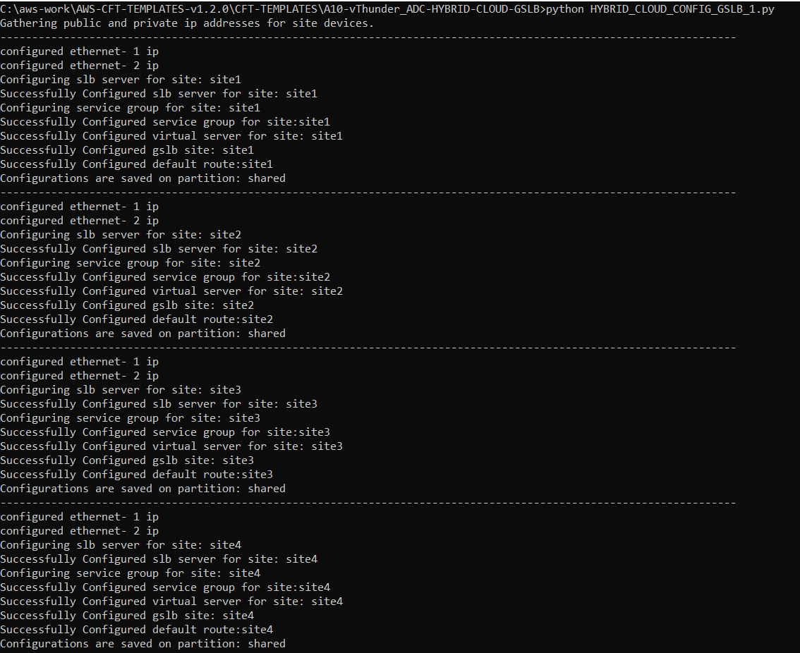

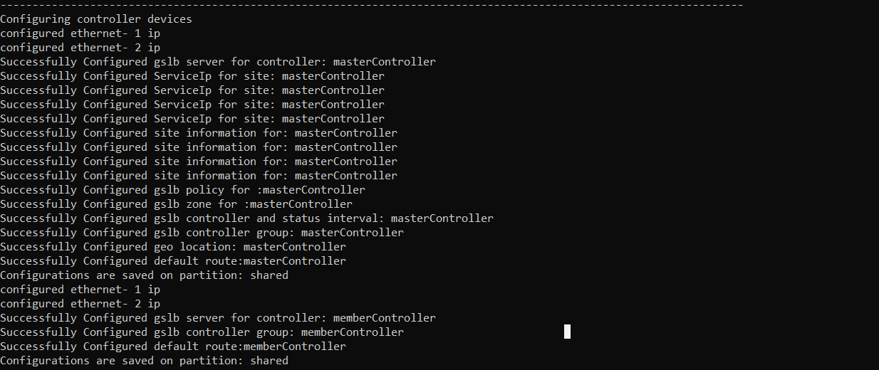

## Step 4: Verify

Login to Thunder via SSH

Open putty and connect with ssh key.

Management IP Address:

User Id [Default]: admin

Master Controller Configurations

1. Run Command : *‘Show running-config’*Text

   Description automatically generated

1. Master Controller – Site 1 configuration:

1. Master Controller – Site 2 Configuration:

1. Execute following command - *show gslb group*

1. Execute following command *show gslb protocol*

Member Controller Configurations:

1. Run Command : *‘Show running-config’*

1. Member Controller – Stie 1 Configuration:

1. Member Controller – Site 2 Configuration:

1. Execute following command - *show gslb group*

1. Execute following command *show gslb protocol*

### DNS Query Testing

To verify DNS query resolution on Master Controller:

1. Do DNS query on any outside instance using the master controller's client-side data interface public IP in the following command:

$ **dig** @*master\_controller\_data\_public*\_IP www.gslb.a10.com

The master controller's client-side data interface public IP is used as DNS server IP. You can get this data interface public IP from

**AzureHomepage->Resourcegroup->vthunderInstance->networking->data1Interface->secondayPublicIp**

***$ dig @data-public-IP [www.gslb.a10.com](http://www.gslb.a10.com)***

stopping the site instances of region1 and then running the dig command again.

### Verify Traffic on load balancer using WGET

1. Install apache on any of the 4 servers

***$ sudo apt install apache2***

1. Select the site instance of the corresponding server on which Apache was installed. Copy secondary public ip of data1 interface.

AzureHomepage->Resourcegroup->vthunderInstance->networking->data1Interface->secondayPublicIp

***$ wget @seconday-public-IP***

